
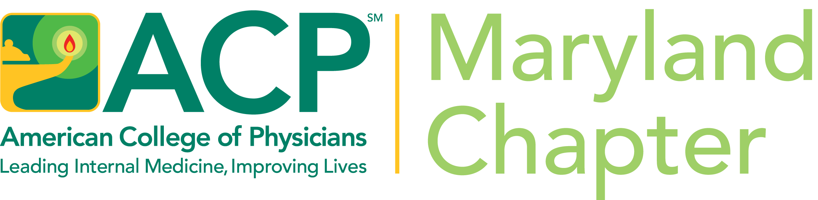

WE INVITE Students, Residents, Faculty & ALL INTERESTED to:

MELTING POT LUCK/HOLIDAY PARTY

THURSDAY, DECEMBER 5, 2024, 6:30 PM
Alagia Auditorium, St. Agnes Hospital
900 Caton Avenue -Baltimore, MD 21229

AN INTERACTIVE WORSHOP YOU CANNOT MISS!

“All the World’s a Stage” – Acting & Improvisation Exercises
to Promote Collaborative Clinical Communication

Presented by: Dr. Bernard “Beau” Landry-Wegener, Assistant Professor – Division of Hospital Medicine, JHUSOM, Former Musical Theater Actor
&
Stories about YOUR Holiday Traditions

We are hoping you will share stories about your traditions among your friends & family.

The MD ACP will provide the main course, drinks and paper goods. However, if you like – you can also bring an appetizer or dessert that celebrates a family tradition or is meaningful to you. Either way, we hope that you will join us!.

If you have any questions, please email Maryellen Woodward at mew4work@aol.com.

To Register please go to this link:

https://docs.google.com/forms/d/1kFrUMXdq4bHI_ZFZnVZ_IDYiGWnHckDJLw4Fm4TzTbU/edit

